Title

Author ^{1*}, Author ^{1,2} and Author ²

¹ Affiliation, City, Country
² Affiliation, City, Country
* corresponding.author@mail.com

Abstract
Use this template to write your abstract. Provide a short description of the paper, including briefly stating the motivation, research objectives, methodology, results, and conclusions. To be published in the local proceedings, abstract must be kept under 250 words, with font Times New Roman, size 10pt, no line spacing. Text must be justified.

Keywords: five; keywords; separated; by; semi-colons

- Introduction
It is expected that authors will submit carefully written and proofread material. Spelling and grammatical errors, as well as language usage problems, are not acceptable. There is no strict limitation to the number of pages, but it is suggested that the short paper length (extended abstract) should not exceed 3000 words and full papers 6000 words.
Papers should clearly describe the background of the subject, the authors' work, including the methods used, as well as concluding discussion on the importance of the work. Papers are to be prepared in English (British or American). Technical terms should be explained unless they are considered to be known to the broader research community. Acronyms should be written out at their first appearance.

  - Fonts
Papers should use 11-point Times New Roman font according to the “Text” style. The styles available are bold, italic and underlined. It is recommended that text in figures is not smaller than 10-point font size.
The document provides the following types of formatting:
- SectionHeading 1;
- SectionHeading 2;
- Highlight Heading 3;
- TableCaption;
- FigureCaption

- Tables and Figures
Figure captions and table headings should be sufficient to explain the figure or table without needing to refer to the text. Figures and tables not cited in the text should not be presented in the paper. The following are example for Table 1 and Figure 1.

Tables and figures should be placed close after their first reference in the text. All figures and tables should be numbered. Table headings should be centered above the tables. Figure captions should be centered below the figures.

Table 1. Title of Example Table
Header | X | Improved
(Flow control valves) Air operated valves | 4 | Yes
Check valves | 2 | Yes
Line discharge check valves | 4 | Yes
Pump discharge check valves | 3 | Yes
Motor driven pumps | 2 | Yes
Motor driven pumps | 2 | No

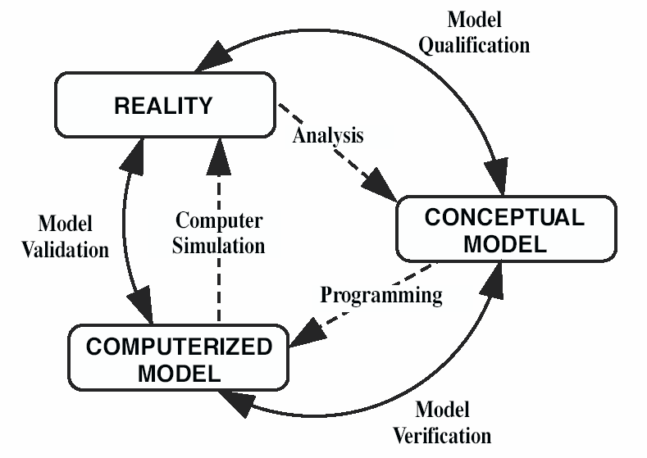
Figure 1: Verification, Validation and Qualification

- Sections
  - Main sections
The titles of the main sections should be placed left and the first letter must be uppercase, using the style SectionHeading 1. Subsections should use SectionHeading 2 style.

Subsections
Whenever there is a need to add more section levels, authors should use HighlightHeading 3. To avoid orphans on the text, make sure that at least three lines of text are typed after the subsection title and before any page break.

- Conclusions
Conclusions should state concisely the most important propositions of the paper, as well as the authors’ views of the implications of the obtained results.

References
References should be placed at the end using Reference style and follow the American Psychological Association (APA) 7th Edition citation style (https://libguides.csudh.edu/citation/apa-7). The references should be listed in alphabetic order.

K.N. Flam, S.B. Rem, G.A. Tim, A. Moss, A. Afzu, Example 1 of Reference for the ICDSST 2019 Short Paper Template, EPRI TR-100382, Electric Power Research Institute, CA., USA, 2002.
N. Watson, Example 2 of Reference for the ICDSST 2021 Short Paper Template, Springer-Verlag, Berlin, Germany, 2010.

